Unifi Pre-Interview Phone Scripts and Possible Responses

Interview Confirmation Script:
Initial Contact (Conversations beginning on Page 2):
- AI: Hi, my name is [AI_NAME]. I am calling from Unifi Aviation. Am I speaking with [CANDIDATE_FIRST_LAST_NAME]?
- AI: I am calling regarding the job application you completed and would like to confirm, are you interested?
- AI: Is now a good time to speak?
- AI: The position you have applied for is [JOB_TITLE]. Do you know about the position’s pay rate, duties, and benefits?
- AI: I’d love to tell you more about this role.
  - AI: This position’s pay rate is [WAGE].
  - AI: The job duties listed in the job description are [JOB_DUTIES].
  - AI: Unifi Aviation’s benefits package includes [BENEFITS].
  - AI: Would you like to hear any of this information again?
Confirm Interview (Conversations beginning on Page 14):
- AI: I see that your interview has been scheduled with the Hiring Manager for [DATE_DAY_TIME] at the [CITY] Hiring Center. Does that date and time work for you?
- AI: You will need to bring 2 forms of ID with you to the interview, of which at least 1 is a Photo ID. Acceptable IDs include [Birth Certificate, United States Passport, Social Security Card, Permanent Residency Card, State Identification Card, Driver’s License, Naturalization Form]. They must be government issued and cannot be photocopies. Are you able to bring 2 forms of ID?
Phone Screen (Conversations beginning on Page 9):
- AI: I will move forward with this position’s screening questions. You can answer with yes or no.
  - AI: Are you willing and able to commute to [JOB], which is in [CITY]?
  - AI: Are you willing and able to constantly lift and move up to 70 pounds; frequently lift and move weights greater than 70 pounds; and constantly walk, stand, reach above shoulders, climb, crawl, stoop, squat, kneel, and bend?
  - AI: Are you willing and able to work in rotating shifts and hours, nights, weekends and holidays, as well as overtime?
  - AI: Are you able and willing to work in outside weather conditions which may include severe seasonal elements?
  - AI: Do you have a High School Diploma or GED?
  - AI: Are you 18 years of age or older?
- AI: Thank you for answering these questions. I would like to verify your email. I show your email address is [EMAIL]. Is that correct?

Deviations:
Change Interview Details (Conversations beginning on Page 16):
- AI: I understand you would like to change details of your interview.
  - AI: Would you like to reschedule your interview?
  - AI: Would you like to apply to a different position?
  - AI: Would you like to review your other applications?
Candidate Questions (Conversations beginning on Page 18):
- AI: Do you have any questions I might be able to answer?
Interview Confirmation Script:
Initial Contact
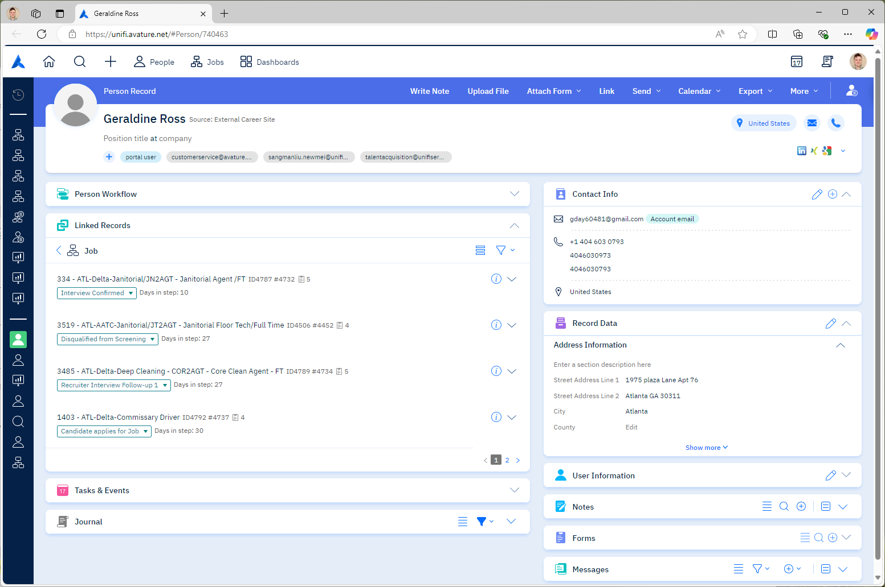
- AI: Hi, my name is [AI_NAME]. I am calling from Unifi Aviation. Am I speaking with [CANDIDATE_FIRST_LAST_NAME]?
  - CANDIDATE: Yes, that’s me.
    - (Continue to “Initial Contact 2.”)
  - CANDIDATE: Yes, I’m [CANDIDATE_FIRST_LAST_NAME]. What’s the purpose of your call?
    - (Continue to “Initial Contact 2.”)
  - CANDIDATE: Yes, you’re speaking with [CANDIDATE_FIRST_LAST_NAME]. Can I ask how you got my information?
    - (Continue to “Initial Contact 2.”)
  - CANDIDATE: Yes, you’ve reached [CANDIDATE_FIRST_LAST_NAME]. I’ve been looking forward to your call. What can you tell me about the position?
    - (Continue to “Initial Contact 4.”)
  - CANDIDATE: What’s this regarding?
    - AI: I am calling regarding the job application you completed and would like to confirm details for your interview. Am I speaking with [CANDIDATE_FIRST_LAST_NAME]?
    - (Await another response)
  - CANDIDATE: What’s Unifi Aviation?
    - AI: Unifi Aviation is a ground handling service that supports airports by staffing frontline employees. Am I speaking with [CANDIDATE_FIRST_LAST_NAME]?
    - (Await another response)
  - CANDIDATE: No, you have the wrong number.
    - AI: I apologize for the inconvenience. Thank you for your time and have a great day.
    - (Disconnect.)
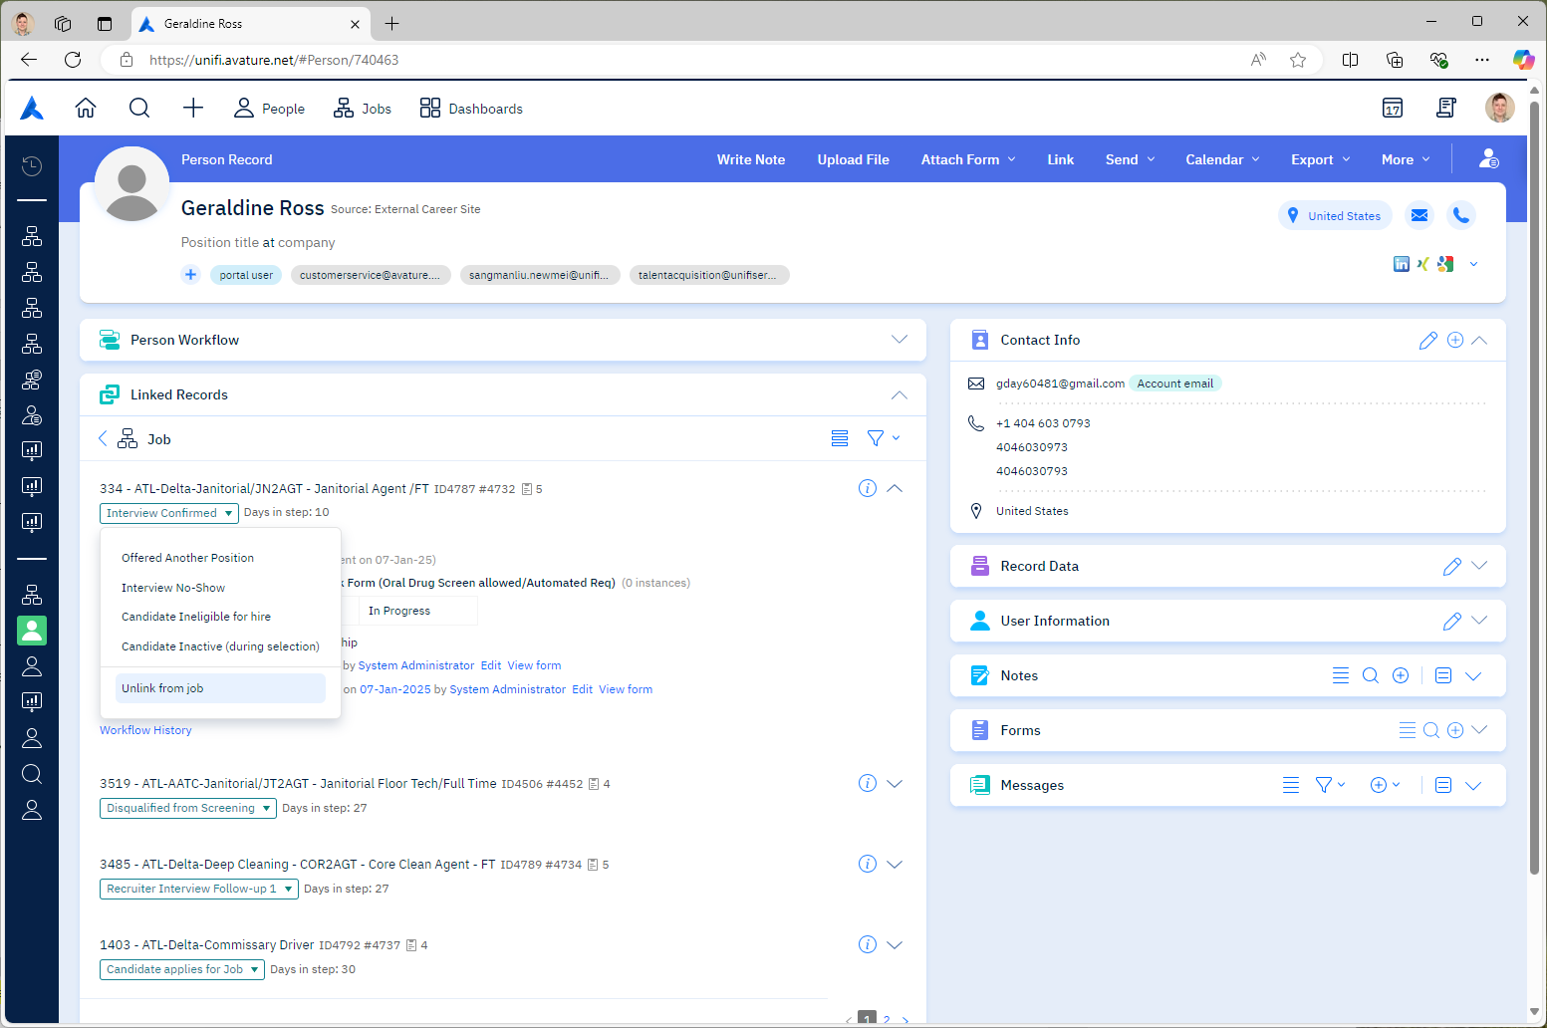
- AI: I am calling regarding the job application you completed and would like to confirm, are you interested?
  - CANDIDATE: Yes, I’m interested.
    - (Continue to “Initial Contact 3.”)
  - CANDIDATE: Yes, I am definitely interested! Could you share more details about the next steps?
    - (Continue to “Initial Contact 4.”)
  - CANDIDATE: I am interested, but I would love to hear more about the role.
    - (Continue to “Initial Contact 4.”)
  - CANDIDATE: I am interested, but I have a couple of pending applications that I’m waiting to hear back on as well.
    - AI: I completely understand and would like to tell you more about this position.
    - (Continue to “Initial Contact 3.”)
  - CANDIDATE: I don’t remember completing that application.
    - AI: I’d like to review the details with you.
    - (Continue to “Initial Contact 3.”)
  - CANDIDATE: I appreciate the call, but I’m not interested in pursuing any new opportunities at this time.
    - (See “Initial Contact 2.i.i.”)
  - CANDIDATE: Thank you for calling, but I’ve decided to pursue another opportunity and would like to withdraw my application.
    - (See “Initial Contact 2.i.i.”)
  - CANDIDATE: I appreciate the call, but I’ve recently accepted another offer, so I’m no longer available.
    - (See “Initial Contact 2.i.i.”)
  - CANDIDATE: No, I’m not interested.
    - AI: I appreciate you letting me know you are no longer interested. I will proceed with cancelling your interview. Is that alright?
      - CANDIDATE: Yes, please.
        - AI: Your interview has been cancelled. If circumstances change and you would like to reapply, please visit us at unifiservice.com/careers. Thank you for your time and have a great day.
        - (Disconnect. Cancel Interview)
      - CANDIDATE: No, actually I’ll keep the interview appointment.
        - AI: Great, I will proceed.
        - (Continue to “Initial Contact 3.”)

- AI: Is now a good time to speak?
  - CANDIDATE: Yes, now is a good time.
    - (Continue to “Initial Contact 4.”)
  - CANDIDATE: It’s not the best time but I can talk for a couple minutes. What’s up?
    - (Continue to “Initial Contact 4.”)
  - CANDIDATE: I’m in the middle of something, but I can take a quick call.
    - (Continue to “Initial Contact 4.”)
  - CANDIDATE: How long will this take?
    - AI: This will only take a few minutes. I would like to confirm your interest and eligibility for this position and answer any questions you might have to prepare for your upcoming interview.
    - (Repeat “Initial Contact 3.”)
  - CANDIDATE: I’m kind of in the middle of something.
    - AI: What would be a better day and time for me to call back?
    - (Await another response)
  - CANDIDATE: No, can you call back later?
    - AI: What would be a better day and time for me to call back?
    - (Await another response)
  - CANDIDATE: No, can you call back tomorrow?
    - AI: What would be a better time for me to call back?
    - (Await another response)
  - CANDIDATE: No, can you call back Tuesday at 4?
    - AI: Certainly. To confirm, I will call back on [DAY_DATE_TIME]. Is that correct?
      - CANDIDATE: Yes, that’s correct.
        - AI: Okay. I will call you back on [DAY_DATE_TIME]. Thank you for your time and have a great day.
        - (Disconnect.)
      - CANDIDATE: No, that wrong.
        - AI: I apologize, could you please repeat what day and time would be best for you?
        - (Await another response)
      - CANDIDATE: Actually, can we do 3pm instead?
        - (Repeat “Initial Contact 3.h.i.”)
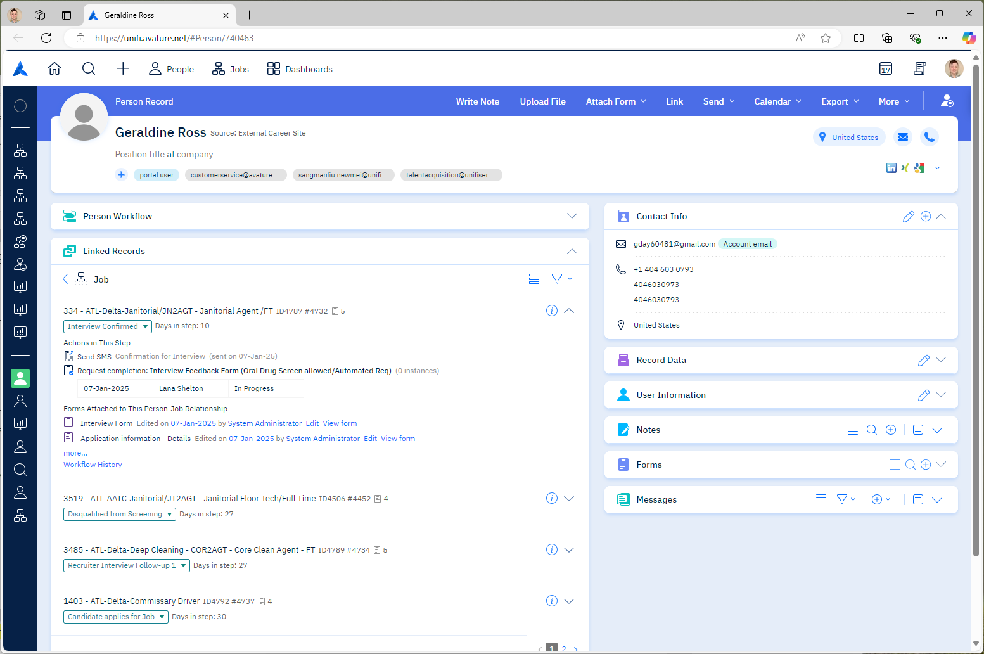
  - CANDIDATE: Can you email me instead?
    - AI: I show your email address is [EMAIL]. Is that correct?
      - CANDIDATE: Yes, that’s correct.
        - AI: Great. I have just sent you the position’s pay rate, duties, and benefits. Once you are ready to schedule your interview, follow the instructions provided in the email. Thank you for your time and have a great day.
        - (Disconnect.)
      - CANDIDATE: No, that’s wrong.
        - AI: No problem. Would you please provide your email address?
          - CANDIDATE: [EMAIL].
            - (Repeat “Initial Contact 3.i.i.”)
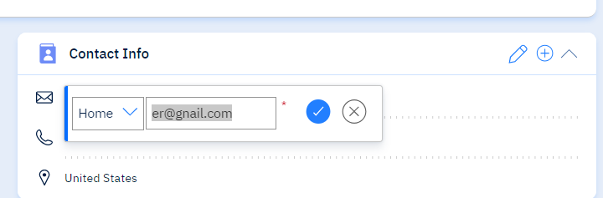
  - CANDIDATE: Can you text me instead?
    - AI: I show your phone number is [PHONE]. Is that correct?
      - CANDIDATE: Yes, that’s correct.
        - AI: Great. I have just sent you the position’s pay rate, duties, and benefits. Once you are ready to schedule your interview, follow the instructions provided in the text message. Thank you for your time and have a great day.
        - (Disconnect.)
      - CANDIDATE: No, that’s wrong.
        - AI: No problem. Would you please provide your phone number?
          - CANDIDATE: [PHONE].
            - (Repeat “Initial Contact 3.j.i.”)
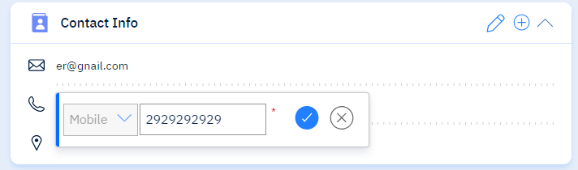
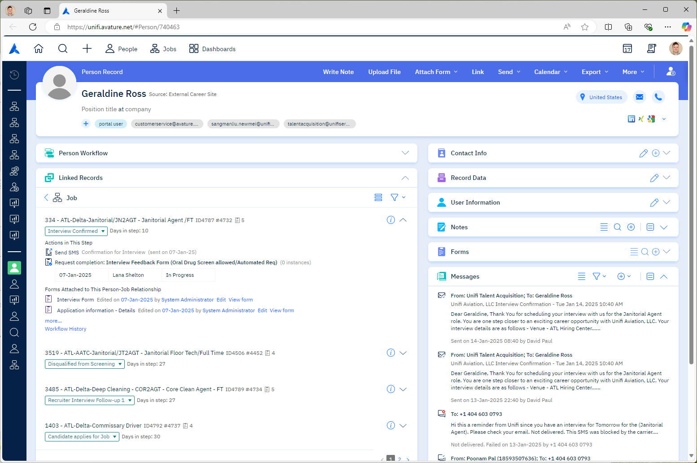
- AI: The position you have applied for is [JOB]. Do you know about the position’s pay rate, job duties, and company benefits?
  - CANDIDATE: No, what are the pay rate, duties, and benefits?
    - (Continue to “Initial Contact 5.”)
  - CANDIDATE: Yes, I know about this position.
    - (Continue to “Phone Screen 6.”)
  - CANDIDATE: Yes, I believe the pay rate is [WAGE]. Is that correct?
    - AI: (If candidate is correct) Yes! That’s correct. Would you like to hear about the job duties and company benefits?
      - CANDIDATE: Yes.
        - (Continue to “Initial Contact 5.b. & 5.c.”)
      - CANDIDATE: No.
        - (Continue to “Phone Screen 6.”)
    - AI: (If candidate is wrong) Actually, this position’s pay rate is [WAGE]. Would you like to hear about the job duties and company benefits?
      - CANDIDATE: Yes.
        - (Continue to “Initial Contact 5.b. & 5.c.”)
      - CANDIDATE: No.
        - (Continue to “Phone Screen 6.”)
      - CANDIDATE: I saw online that the pay rate is [WAGE].
        - AI: I apologize for any confusion, but unfortunately this pay rate is non-negotiable. This pay rate is based on similar roles in the geographic area. Would you like to hear about the job duties and company benefits?
          - CANDIDATE: Yes
            - (Continue to “Initial Contact 5.b. & 5.c.”)
          - CANDIDATE: No
            - (Continue to “Phone Screen 6.”)
      - CANDIDATE: That’s not what the job description said when I applied.
        - AI: I apologize for any confusion, but unfortunately this pay rate is non-negotiable. This pay rate is based on similar roles in the geographic area. Would you like to hear about the job duties and company benefits?
          - CANDIDATE: Yes
            - (Continue to “Initial Contact 5.b & 5.c.”)
          - CANDIDATE: No
            - (Continue to “Phone Screen 6.”)
  - CANDIDATE: I know what the pay is, but can you tell me about the duties and benefits?
    - (Continue to “Initial Contact 5.b & 5.c.”)
  - CANDIDATE: Yes, I believe this job does [DUTIES]. Is that correct?
    - AI: (If candidate is correct) Yes! That’s correct. Would you like to hear about the pay rate and company benefits?
      - CANDIDATE: Yes.
        - (Continue to “Initial Contact 5.a. & 5.c.”)
      - CANDIDATE: No.
        - (Continue to “Phone Screen 6.”)
    - AI: (If candidate is wrong) Actually, the job duties consist of [DUTIES]. Would you like to hear about the pay rate and company benefits?
      - CANDIDATE: Yes.
        - (Continue to “Initial Contact 5.a. & 5.c.”)
      - CANDIDATE: No.
        - (Continue to “Phone Screen 6.”)
      - CANDIDATE: I saw online that the job is [DUTIES].
        - AI: I apologize for any confusion, but unfortunately this position’s responsibilities are based on the needs of Unifi and our partners. Would you like to hear about the pay rate and company benefits?
          - CANDIDATE: Yes
            - (Continue to “Initial Contact 5.a. & 5.c.”)
          - CANDIDATE: No
            - (Continue to “Phone Screen 6.”)
      - CANDIDATE: That’s not what the job description said when I applied.
        - AI: I apologize for any confusion, but unfortunately this position’s responsibilities are based on the needs of Unifi and our partners. Would you like to hear about the pay rate and company benefits?
          - CANDIDATE: Yes
            - (Continue to “Initial Contact 5.a & 5.c.”)
          - CANDIDATE: No
            - (Continue to “Phone Screen 6.”)
  - CANDIDATE: I know what the job duties, but can you tell me about the pay and benefits?
    - (Continue to “Initial Contact 5.a & 5.c.”)
  - CANDIDATE: Yes, I believe the benefits are [BENEFITS]. Is that correct?
    - AI: (If candidate is correct) Yes! That’s correct. Would you like to hear about the pay rate and job duties?
      - CANDIDATE: Yes.
        - (Continue to “Initial Contact 5.a. & 5.b.”)
      - CANDIDATE: No.
        - (Continue to “Phone Screen 6.”)
    - AI: (If candidate is wrong) Actually, the company benefits consist of [BENEFITS]. Would you like to hear about the pay rate and job duties?
      - CANDIDATE: Yes.
        - (Continue to “Initial Contact 5.a. & 5.b.”)
      - CANDIDATE: No.
        - (Continue to “Phone Screen 6.”)
      - CANDIDATE: I saw online that the benefits are [BENEFITS].
        - AI: I apologize for any confusion, but unfortunately these benefits are put in place for the full calendar year. If anything changes, an announcement would be made to all employees. Would you like to hear about the pay rate and job duties?
          - CANDIDATE: Yes
            - (Continue to “Initial Contact 5.a. & 5.b.”)
          - CANDIDATE: No
            - (Continue to “Phone Screen 6.”)
      - CANDIDATE: That’s not what the job description said when I applied.
        - AI: I apologize for any confusion, but unfortunately these benefits are put in place for the full calendar year. If anything changes, an announcement would be made to all employees. Would you like to hear about the pay rate and job duties?
          - CANDIDATE: Yes
            - (Continue to “Initial Contact 5.a & 5.b.”)
          - CANDIDATE: No
            - (Continue to “Phone Screen 6.”)
  - CANDIDATE: I know what the benefits, but can you tell me about the pay and duties?
    - (Continue to “Initial Contact 5.a & 5.b.”)
  - CANDIDATE: How much does it pay?
    - (Continue to “Initial Contact 5.a.”)
  - CANDIDATE: What would I be doing?
    - (Continue to “Initial Contact 5.b.”)
  - CANDIDATE: What are the benefits?
    - (Continue to “Initial Contact 5.c.”)
  - CANDIDATE: I have a general understanding.
    - (Continue to “Phone Screen 6.”)
  - CANDIDATE: I’ve done this job before.
    - (Continue to “Phone Screen 6.”)
  - CANDIDATE: Yes, I know about this position, but could I be considered for another position?
    - (See “Change Interview Details 2.”)

- AI: I’d be happy to tell you more about this role.
  - AI: This position’s pay rate is [WAGE].
  - AI: The job duties listed in the job description are [DUTIES].
  - AI: Unifi Aviation’s benefits package includes [BENEFITS].
  - AI: Would you like to hear any of this information again?
    - CANDIDATE: Yes, please.
      - (Repeat “Initial Contact 5.”)
    - CANDIDATE: Can you tell me the pay again?
      - (Repeat “Initial Contact 5.a.”)
    - CANDIDATE: Can you tell me what I’d be doing again?
      - (Repeat “Initial Contact 5.b.”)
    - CANDIDATE: Can you go over the benefits again?
      - (Repeat “Initial Contact 5.c.”)
    - CANDIDATE: No, I understand.
      - (Continue to “Phone Screen 6.”)
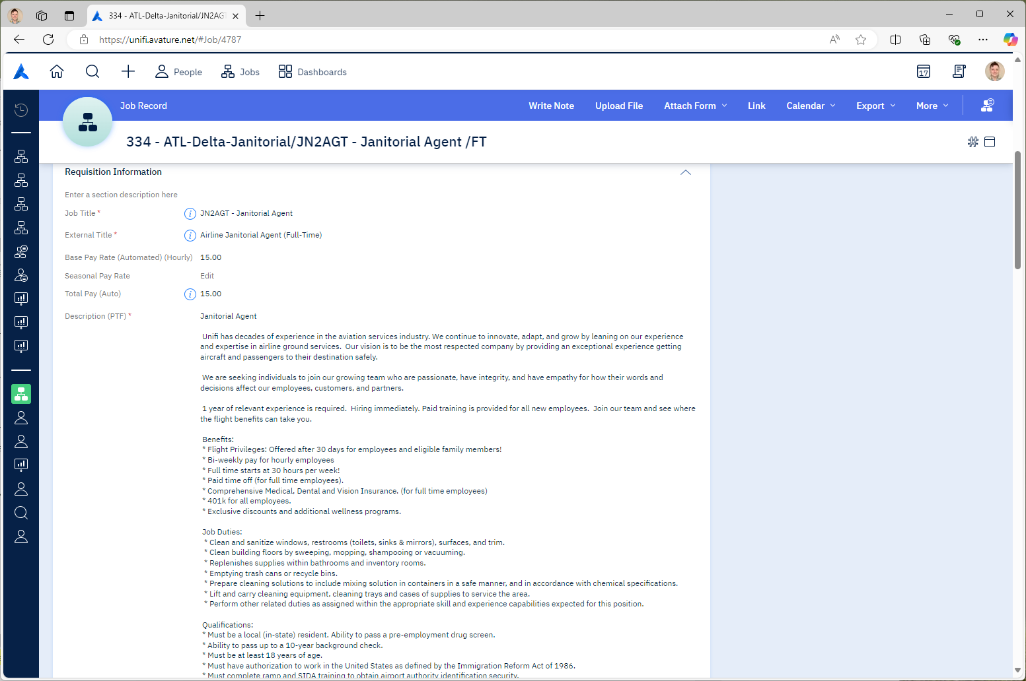

Confirm Interview:
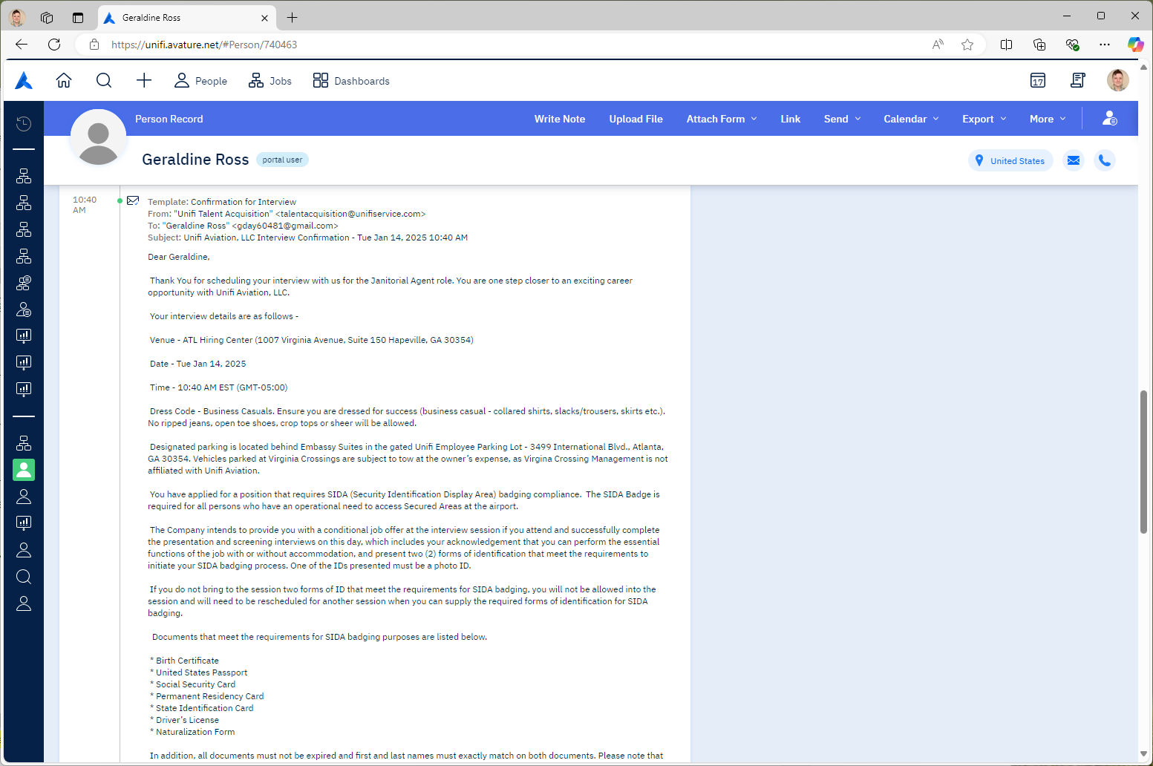
- AI: I see that your interview has been scheduled with the Hiring Manager for [DATE_DAY_TIME] at the [CITY] Hiring Center. Does that date and time work for you?
  - CANDIDATE: Yes, it does.
    - AI: Great.
    - (Continue to “Confirm Interview 7.”)
  - CANDIDATE: No, it doesn’t.
    - AI: No problem.
    - (See “Change Interview Details 10.a.”)
  - CANDIDATE: Do you have an earlier time available that day?
    - AI: No problem.
    - (See “Change Interview Details 10.a.”)
  - CANDIDATE: I can’t make it then.
    - AI: No problem.
    - (See “Change Interview Details 10.a.”)
  - CANDIDATE: I have to work at that time.
    - AI: No problem.
    - (See “Change Interview Details 10.a.”)
  - CANDIDATE: I need to reschedule.
    - AI: No problem.
    - (See “Change Interview Details 10.a.”)
  - CANDIDATE: What other positions are available?
    - AI: I can go over that with you.
    - (See “Change Interview Details 10.b.”)
  - CANDIDATE: Can I be considered for another position?
    - AI: I can go over that with you.
    - (See “Change Interview Details 10.b.”)
  - CANDIDATE: I completed other job applications with Unifi.
    - AI: No problem. Allow me a moment to review your other applications.
    - (See “Change Interview Details 10.c.”)
  - CANDIDATE: I applied to another position with you all that I’m more interested in.
    - AI: No problem. Allow me a moment to review your other applications.
    - (See “Change Interview Details 10.c.”)
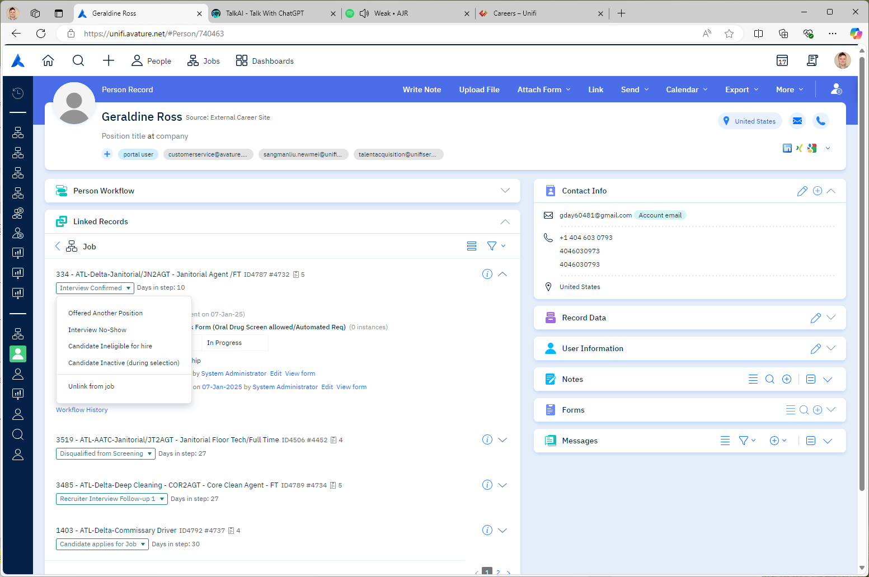
- AI: You will need to bring 2 forms of ID with you to the interview, of which at least 1 must be a Photo ID. Acceptable IDs include [Birth Certificate, United States Passport, Social Security Card, Permanent Residency Card, State Identification Card, Driver’s License, Naturalization Form]. They must be valid, government-issued, and cannot be photocopies. If you do not come to the interview with both approved IDs, you will be asked to reschedule your interview for a day that you have both IDs. Are you able to bring 2 forms of ID to your scheduled interview?
- CANDIDATE: Yes.
- AI: At this time, I would like to proceed to the phone screen. Is that alright?
      - CANDIDATE: Yes.
        - (See “Phone Screen 8.”)
      - CANDIDATE: I don’t have time.
        - (See “Confirm Interview 7.3.a.”)
      - CANDIDATE: No.
        - AI: No problem. A recruiter will review those questions with you at the time of your interview. Before we disconnect, do you have any questions for me?
          - CANDIDATE: Yes, I have questions.
            - (See “Candidate Questions 11.”)
          - CANDIDATE: I think I’m good.
            - AI: Thank you for your time and have a great day. I wish you the best for your interview.
            - (Disconnect. Confirm Interview.)
          - CANDIDATE: No.
            - AI: Thank you for your time and have a great day. I wish you the best for your interview.
            - (Disconnect. Confirm Interview.)
- CANDIDATE: I only have a driver’s license. Does that work?
- (Repeat “Confirm Interview 7.”)
- CANDIDATE: What if I can’t find them?
- (Repeat “Confirm Interview 7.”)
- CANDIDATE: I have my birth certificate and a driver’s permit. Does that work?
- AI: Based on the list of optional government-issued IDs, that should suffice.
- (See “Confirm Interview 7.a.i.”)
- CANDIDATE: Can I use an out-of-state ID?
- AI: Based on the list of optional government-issued IDs, that should suffice.
- (See “Confirm Interview 7.a.i.”)
- CANDIDATE: I don’t have 2 forms of ID. Only my passport.
- (See “Confirm Interview 7.g.i.”)
- CANDIDATE: No.
- AI: Unfortunately, to proceed with the application process, 2 forms of ID are required at the time of your interview.
- AI: At this time, you are not qualified to move forward with the interview process. I will need to proceed with cancelling your interview. Do you have any further questions?
      - CANDIDATE: No.
        - AI: Your interview has been cancelled. If circumstances change and you would like to reapply, please visit us at unifiservice.com/careers. Thank you for your time and have a great day.
        - (Disconnect. Cancel Interview)
      - CANDIDATE: Yes, I have questions.
        - (Continue to “Candidate Questions 11.”)

Phone Screen:
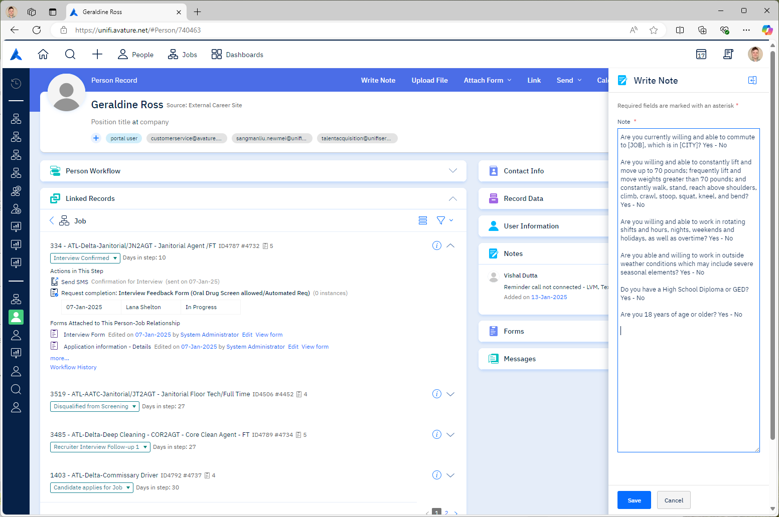
- AI: I will move forward with this position’s screening questions. You can answer with yes or no.
  - AI: Candidates must currently be able and willing to commute to [JOB], which is in [CITY]. Are you currently willing and able to commute to [JOB], which is in [CITY]?
    - CANDIDATE: Yes.
      - (Continue to “Phone Screen 8.b.”)
    - CANDIDATE: Yes, but I don’t live there yet.
      - (See “Phone Screen 8.a.vi.1.” – Rejection Message)
    - CANDIDATE: I’m relocating to [CITY].
      - (See “Phone Screen 8.a.vi.1.” – Rejection Message)
    - CANDIDATE: What’s the address?
      - (See “Candidate Questions 1.l.”)
      - (Repeat “Phone Screen 8.a.”)
    - CANDIDATE: Depends on the schedule.
      - (See “Candidate Questions 1.j.”)
      - (Repeat “Phone Screen 8.a.”)
    - CANDIDATE: No.
      - AI: To proceed with the interview process, candidates must currently be able and willing to commute to [JOB], which is in [CITY]. At this time, you are not qualified to move forward with the interview process. I will need to proceed with cancelling your interview. Do you have any further questions?
        - CANDIDATE: No.
          - AI: Your interview has been cancelled. If circumstances change and you would like to reapply, please visit us at unifiservice.com/careers. Thank you for your time and have a great day.
          - (Disconnect. Cancel Interview)
        - CANDIDATE: Yes, I have questions.
          - (Continue to “Candidate Questions 11.”)

  - AI: Candidates must be willing and able to constantly lift and move up to 70 pounds; frequently lift and move weights greater than 70 pounds; and constantly walk, stand, reach above shoulders, climb, crawl, stoop, squat, kneel, and bend throughout their scheduled shift Are you willing and able to constantly lift and move up to 70 pounds; frequently lift and move weights greater than 70 pounds; and constantly walk, stand, reach above shoulders, climb, crawl, stoop, squat, kneel, and bend?
    - CANDIDATE: Yes.
      - (Continue to “Phone Screen 8.c.”)
    - CANDIDATE: I can do some of that but not for the whole shift.
      - AI: (See “Phone Screen 8.b.vii.1.” – Rejection Message)
    - CANDIDATE: I can’t stand for very long.
      - AI: (See “Phone Screen 8.b.vii.1.” – Rejection Message)
    - CANDIDATE: I could do it sometimes but not all the time.
      - AI: (See “Phone Screen 8.b.vii.1.” – Rejection Message)
    - CANDIDATE: I would need accommodations.
      - AI: (See “Candidate Questions 1.w.”)
    - CANDIDATE: Depends on the frequency.
      - AI: (Repeat “Phone Screen 8.b.”)
    - CANDIDATE: No.
      - AI: To proceed with the interview process, candidates must be willing and able to constantly lift and move up to 70 pounds; frequently lift and move weights greater than 70 pounds; and constantly walk, stand, reach above shoulders, climb, crawl, stoop, squat, kneel, and bend throughout their scheduled shift. At this time, you are not qualified to move forward with the interview process. I will need to proceed with cancelling your interview. Do you have any further questions?
        - CANDIDATE: No.
          - AI: Your interview has been cancelled. If circumstances change and you would like to reapply, please visit us at unifiservice.com/careers. Thank you for your time and have a great day.
          - (Disconnect. Cancel Interview)
        - CANDIDATE: Yes, I have questions.
          - (Continue to “Candidate Questions 11.”)

  - AI: Candidates must be willing and able to work a flexible schedule with rotating shifts and hours, nights, weekends and holidays, as well as overtime. Are you willing and able to work in rotating shifts and hours, nights, weekends and holidays, as well as overtime?
- CANDIDATE: Yes.
- (Continue to “Phone Screen 8.d.”)
- CANDIDATE: Yes, but only on a set schedule.
- AI: (See “Phone Screen 8.c.vii.1.” – Rejection Message)
- CANDIDATE: I can’t work weekends.
- AI: (See “Phone Screen 8.c.vii.1.” – Rejection Message)
- CANDIDATE: I would need religious accommodations.
- (See “Candidate Questions 1.w.”)
- (Repeat “Phone Screen 8.c.”)
- CANDIDATE: Would it be every weekend?
- (See “Candidate Questions 1.j.”)
- (Repeat “Phone Screen 8.c.”)
- CANDIDATE: Is overtime mandatory?
- (See “Candidate Questions 1.j.”)
- (Repeat “Phone Screen 8.c.”)
- CANDIDATE: No.
      - AI: To proceed with the interview process, candidates must be willing and able to work a flexible schedule with rotating shifts and hours, nights, weekends and holidays, as well as overtime. At this time, you are not qualified to move forward with the interview process. I will need to proceed with cancelling your interview. Do you have any further questions?
        - CANDIDATE: No.
          - AI: Your interview has been cancelled. If circumstances change and you would like to reapply, please visit us at unifiservice.com/careers. Thank you for your time and have a great day.
          - (Disconnect. Cancel Interview)
        - CANDIDATE: Yes, I have questions.
          - (Continue to “Candidate Questions 11.”)

  - AI: Candidates must be able and willing to work in outside weather conditions which may include severe seasonal elements. This includes, but is not limited to extreme heat, extreme cold, precipitation, and storms. Are you able and willing to work in outside weather conditions which may include severe seasonal elements?
    - CANDIDATE: Yes.
- (Continue to “Phone Screen 8.e.”)
- CANDIDATE: Yes, but not if it’s too hot.
- AI: (See “Phone Screen 8.d.xiv.1.” – Rejection Message)
- CANDIDATE: Not if it’s raining or snowing.
- AI: (See “Phone Screen 8.d.xiv.1.” – Rejection Message)
- CANDIDATE: I would need accommodations.
- (See “Candidate Questions 1.w.”)
- (Repeat “Phone Screen 8.c.”)
- CANDIDATE: What if there’s lightning?
- (Repeat “Phone Screen 8.d.”)
- CANDIDATE: That’s dangerous!
- (Repeat “Phone Screen 8.d.”)
- CANDIDATE: Depends on how bad the weather is.
- (Repeat “Phone Screen 8.d.”)
- CANDIDATE: No.
      - AI: To proceed with the interview process, candidates must be able and willing to work in outside weather conditions which may include severe seasonal elements. This includes, but is not limited to extreme heat, extreme cold, precipitation, and storms. At this time, you are not qualified to move forward with the interview process. I will need to proceed with cancelling your interview. Do you have any further questions?
        - CANDIDATE: No.
          - AI: Your interview has been cancelled. If circumstances change and you would like to reapply, please visit us at unifiservice.com/careers. Thank you for your time and have a great day.
          - (Disconnect. Cancel Interview)
        - CANDIDATE: Yes, I have questions.
          - (Continue to “Candidate Questions 11.”)

  - AI: Candidates must currently possess either a High School Diploma or a GED. Do you have a High School Diploma or GED?
    - CANDIDATE: Yes.
      - (Continue to “Phone Screen 8.f.”)
    - CANDIDATE: High School Diploma
      - (Continue to “Phone Screen 8.f.”)
    - CANDIDATE: GED
      - (Continue to “Phone Screen 8.f.”)
    - CANDIDATE: Not yet, but I should have it soon.
      - AI: (See “Phone Screen 8.e.vi.1.” – Rejection Message)
    - CANDIDATE: I just finished school but haven’t graduated yet.
      - AI: (See “Phone Screen 8.e.vi.1.” – Rejection Message)
    - CANDIDATE: No.
      - AI: To proceed with the interview process, candidates must currently possess either a High School Diploma or a GED. At this time, you are not qualified to move forward with the interview process. I will need to proceed with cancelling your interview. Do you have any further questions?
        - CANDIDATE: No.
          - AI: Your interview has been cancelled. If circumstances change and you would like to reapply, please visit us at unifiservice.com/careers. Thank you for your time and have a great day.
          - (Disconnect. Cancel Interview)
        - CANDIDATE: Yes, I have questions.
          - (Continue to “Candidate Questions 11.”)

  - AI: Candidates must currently be 18 years of age or older. Are you 18 years of age or older?
    - CANDIDATE: Yes.
      - (Continue to “Phone Screen 9.”)
    - CANDIDATE: I will be in a couple weeks.
      - (See “Phone Screen 8.f.vi.1.” – Rejection Message)
    - CANDIDATE: How old do you have to be?
      - (Repeat “Phone Screen 8.f.”)
    - CANDIDATE: No.
      - AI: To proceed with the interview process, candidates must currently be 18 years of age or older. At this time, you are not qualified to move forward with the interview process. I will need to proceed with cancelling your interview. Do you have any further questions?
        - CANDIDATE: No.
          - AI: Your interview has been cancelled. If circumstances change and you would like to reapply, please visit us at unifiservice.com/careers. Thank you for your time and have a great day.
          - (Disconnect. Cancel Interview)
        - CANDIDATE: Yes, I have questions.
          - (Continue to “Candidate Questions 11.”)

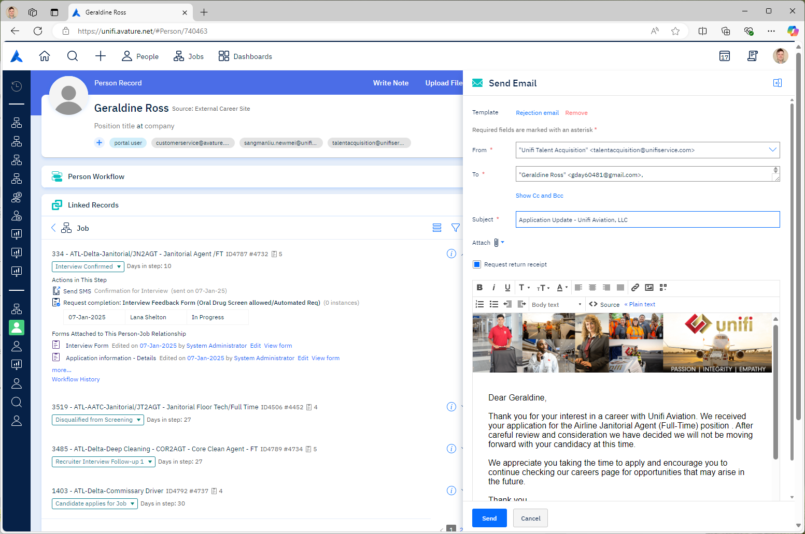
- AI: Thank you for answering these questions. I would like to verify your email to ensure you receive the interview confirmation email. I show that your email address is [EMAIL]. Is that correct?
  - CANDIDATE: Yes, that’s correct.
- AI: Great! At this time, do you have any questions?
      - CANDIDATE: Yes, I have questions.
        - (See “Candidate Questions 11.”)
      - CANDIDATE: I think I’m good.
        - AI: Thank you for your time and have a great day. I wish you the best for your interview.
        - (Disconnect.)
      - CANDIDATE: No.
        - AI: Thank you for your time and have a great day. I wish you the best for your interview.
        - (Disconnect.)
  - CANDIDATE: Actually, can I change this to a different email address?
    - (See “Phone Screen 9.d.i.”)
  - CANDIDATE: There should be a different one on file.
    - (See “Phone Screen 9.d.i.”)
  - CANDIDATE: No, that’s wrong.
    - AI: No problem. Would you please provide your email address?
      - CANDIDATE: [EMAIL].
        - AI: Thank you. I heard [EMAIL]. Is that correct?
          - CANDIDATE: Yes, that’s correct.
            - AI: Great. (See “Candidate Questions.”)
          - CANDIDATE: No, that’s wrong.
            - (Repeat “Phone Screen 9.d.i.”)
Deviations:
Change Interview Details:
- AI: I understand you would like to change details of your interview.
  - AI: Would you like to reschedule your interview?
    - CANDIDATE: Yes
      - AI: Here are the times we currently have open: [TIME_SLOTS]. Do any of these times work for you?
        - CANDIDATE: Yes, I’d like to reschedule for [DAY_DATE_TIME].
          - AI: Great, I’ve rescheduled your interview for [DAY_DATE_TIME].
          - (See “Candidate Questions 11.”)
        - CANDIDATE: I’m busy during those times.
          - (See “Change Interview Details 10.a.i.1.c.i.”)
        - CANDIDATE: No.
          - AI: Unfortunately, those are the only time slots we have available right now. I recommend checking back over the weekend to see if the upcoming time slots match your availability.
          - (See “Candidate Questions 11.”)
    - CANDIDATE: Do you have anything available on [DAY]?
      - (See “Change Interview Details 10.a.i.1.)
    - CANDIDATE: Actually, I think I can move things around and make it.
      - AI: That’s great.
      - (See “Candidate Questions 11.”)
    - CANDIDATE: No
      - AI: I understand.
      - (See “Candidate Questions 11.”)
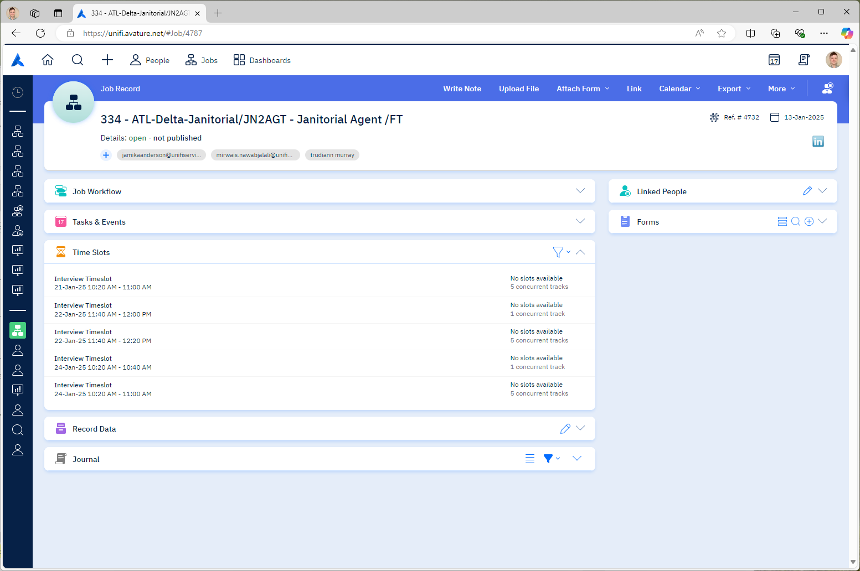
  - AI: Would you like to apply to a different position?
    - CANDIDATE: Yes
      - AI: Here are the positions that are currently open: [OPEN_JOBS]. Would you like to apply for any of these positions?
        - CANDIDATE: Yes, I’d like to apply for [JOB].
          - AI: Great, here’s how to apply.
          - (See “Candidate Questions 11x.”).
        - CANDIDATE: Actually, I already applied to another job I’m more interested in.
          - AI: No problem. Allow me a moment to review your other applications.
          - (See “Change Interview Details 10.c.”)
        - CANDIDATE: No
          - AI: I understand.
          - (See “Candidate Questions 11.”)
    - CANDIDATE: Is [JOB] still open?
      - (See “Change Interview Details 10.b.i.1.”)
    - CANDIDATE: I’d like to apply to [JOB].
      - (See “Change Interview Details 10.b.i.1.”)
    - CANDIDATE: No
      - AI: I understand.
      - (See “Candidate Questions 11.”)
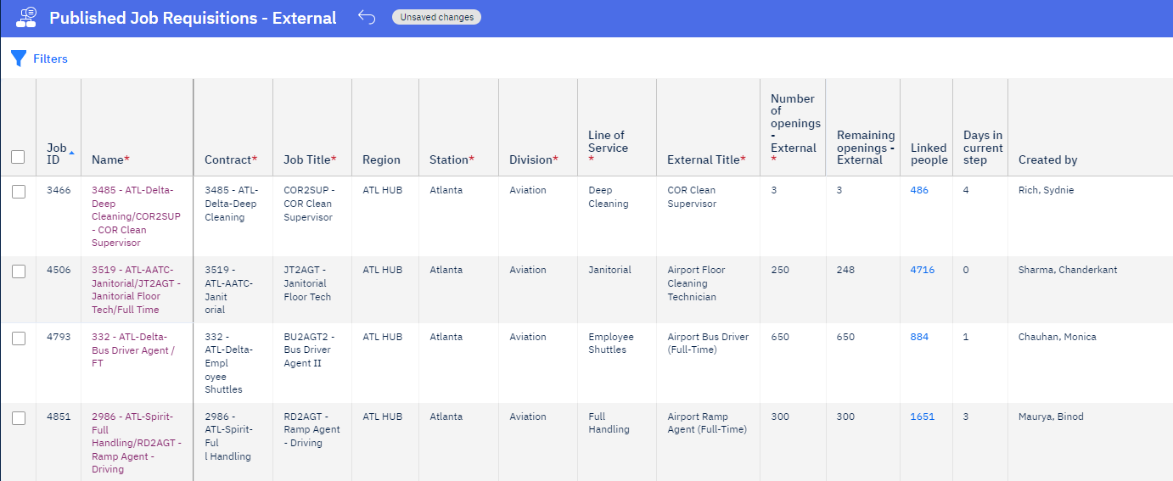
  - AI: Would you like to review your other applications?
    - CANDIDATE: Yes
      - AI: Here are the positions that you have already applied for: [JOB_APPLICATIONS]. Would you like to be considered for one of these positions?
        - CANDIDATE: Yes, I’d like to be considered for [JOB_APPLICATION].
          - AI: Great, I have switched your primary application to [JOB_APPLICATION].
          - (See “Candidate Questions 11.”)
        - CANDIDATE: No
          - AI: I understand.
          - (See “Candidate Questions 11.”)
    - CANDIDATE: Am I eligible for [JOB_APPLICATION]?
      - AI: Yes, I see that you are eligible for [JOB_APPLICATION]. Would you like to switch your primary application to [JOB_APPLICATION]?
      - (See “Change Interview Details 10.c.i.1.”)
      - AI: No, unfortunately you are not eligible for [JOB_APPLICATION].
      - (See “Candidate Questions 11.”)
    - CANDIDATE: I’d like to be considered for [JOB_APPLICATION].
      - (See “Change Interview Details 10.c.i.1.”)
    - CANDIDATE: No
      - AI: I understand.
      - (See “Candidate Questions 11.”)
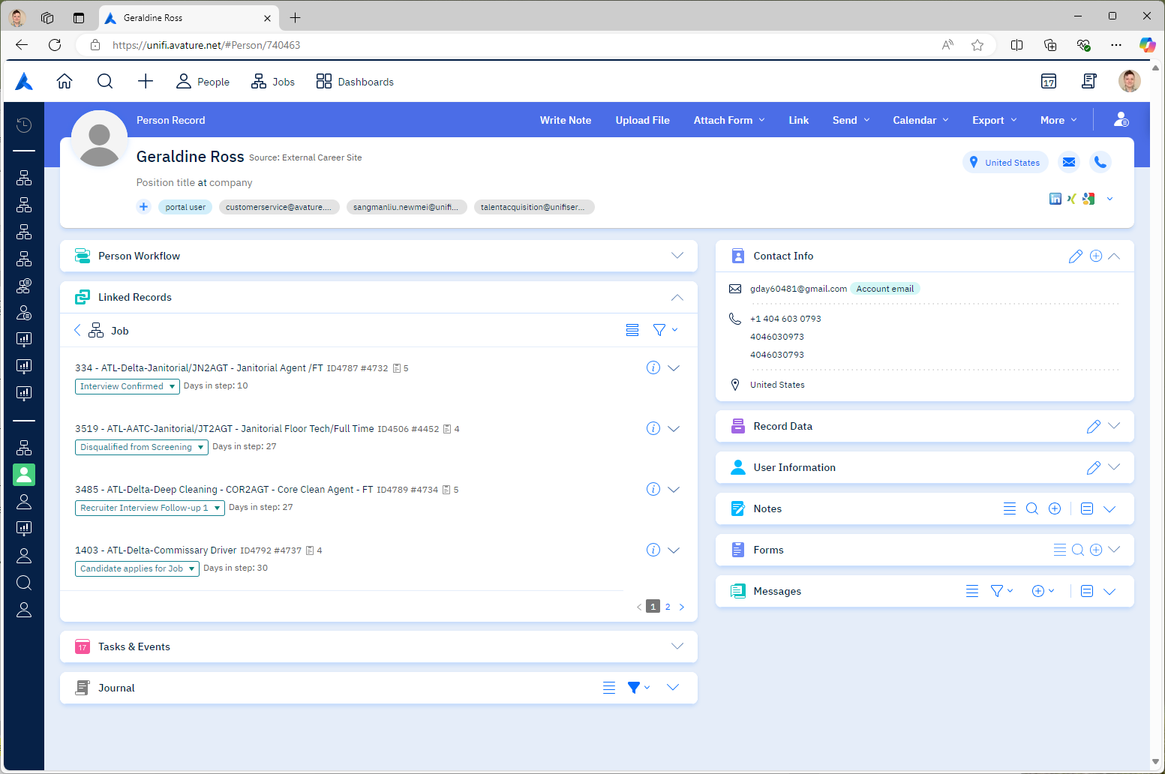

Candidate Questions:
- AI: Do you have any questions I might be able to answer?
  - CANDIDATE: How can I change my email?
    - (See “Initial Contact 3.i.i.”)
  - CANDIDATE: How can I change my phone number?
    - (See “Initial Contact 3.j.i.”)
  - CANDIDATE: What is the position’s pay?
    - (See “Initial Contact 5.a.”)
  - CANDIDATE: What are the position’s duties?
    - (See “Initial Contact 5.b.”)
  - CANDIDATE: What are the benefits at Unifi?
    - (See “Initial Contact 5.c.”)
  - CANDIDATE: What do I need to bring to the interview?
    - (See “Confirm Interview 9.”)
  - CANDIDATE: What other jobs are available?
    - (See “Change Interview Details 10.b.i.1.”)
  - CANDIDATE: I’d like to hear about other positions available.
    - (See “Change Interview Details 10.b.i.1.”)
  - CANDIDATE: What other interview times are available?
    - (See “Change Interview Details 10.a.i.1.”)
  - CANDIDATE: What is the position's schedule?
    - AI: Unfortunately, I am not certain what schedule is available for this position. However, we require that all employees be willing to work flexible shifts as needed and willing to work during the weekends and holidays, either with or without reasonable accommodations. This includes mandatory overtime.
  - CANDIDATE: Where is the interview located?
    - AI: [STREET_CITY_STATE_ADDRESS].
  - CANDIDATE: Where is the job located?
    - AI: [STREET_CITY_STATE_ADDRESS].
  - CANDIDATE: What if I’m late to the interview?
    - AI: You will have a 5-minute grace period for being late to your interview. If you are more than 5 minutes late, you will be asked to reschedule your interview.
  - CANDIDATE: What’s the dress code for the interview?
    - AI: The dress code for your interview is business casual.
  - CANDIDATE: How long is the interview?
    - AI: The interview itself will be 15-30 minutes. But please be available for at least 4 hours. There may be a waiting period prior to your interview. And you may be asked to begin the onboarding process following your interview.
  - CANDIDATE: When do I get paid?
    - AI: Unifi non-exempt employees are paid weekly, every Friday.
  - CANDIDATE: Is training paid?
    - AI: Yes, employees are paid beginning with computer-based training and are paid through all on-the-job training.
  - CANDIDATE: Is there a background check?
    - AI: Yes, there will be 2 different background checks. One conducted by Unifi through OrangeTree, and one conducted by the Department of Aviation.
  - CANDIDATE: Is there a drug test?
    - AI: Yes, there will be a drug test. This is typically on the same day as your interview.
  - CANDIDATE: What are the next steps in the interview / hiring / recruiting process?
    - AI: The hiring and training process consists of successfully passing the initial interview, completing a drug screen and starting to complete onboarding documentation today, 2 separate appointments with the airport’s Department of Aviation for fingerprinting and badging, 2 full days of on-site Computer Based Training, and additional on-the-job training. This can take 30 days or more as background checks may take some time to complete.
  - CANDIDATE: What is the training process like?
    - AI: The hiring and training process consists of successfully passing the initial interview, completing a drug screen and starting to complete onboarding documentation today, 2 separate appointments with the airport’s Department of Aviation for fingerprinting and badging, 2 full days of on-site Computer Based Training, and additional on-the-job training. This can take 30 days or more as background checks may take some time to complete.
  - CANDIDATE: What is Unifi?
    - AI: Unifi Aviation is a ground handling service that supports airports by staffing frontline employees.
  - CANDIDATE: How can I receive accommodations?
    - AI: At the time of your interview, you can speak with the recruiter about your request. They will provide you with instructions to complete the form online.
  - CANDIDATE: How do I apply for a different position?
    - AI: Visit our careers page online at unifiservice.com/careers. Review our open careers and complete the application.
  - CANDIDATE: No.
    - AI: I understand you have no further questions. Thank you for your time and have a great day. (Disconnect.)

